UNIVERSITY OF WOLVERHAMPTON

School of Architecture, Computing & Engineering

MSc Computer Science
Research Progress Report

Supervisor
Dr. Daw Phyu Phyu Khaing



TITLE OF DISSERTATION
Design and Evaluation of a Deep Learning Framework for AI-Generated Image Detection Using Transfer Learning
Name of Candidate
Kyi Phyu Aung

1.Introduction
Artificial Intelligence (AI) has rapidly transformed the field of digital content creation. Modern image generation models such as Midjourney, Stable Diffusion, DALL·E, FLUX, and other diffusion-based systems are now capable of producing highly realistic images that are often difficult for humans to distinguish from authentic photographs. As these technologies continue to improve, AI-generated images are increasingly used across social media, journalism, education, entertainment, and commercial applications. While these advancements offer many positive opportunities, they also introduce serious concerns regarding misinformation, identity manipulation, copyright infringement, and digital trust.
The ability to accurately distinguish between real and AI-generated images has therefore become an important research challenge. Numerous deep learning approaches have been proposed for AI image detection; however, many existing methods perform well only when evaluated on images generated by the same model used during training. When confronted with images produced by previously unseen generators, detection performance often decreases significantly. This limitation, commonly referred to as the cross-generator generalization problem, reduces the practical applicability of many existing AI image detectors.
This research investigates whether transfer learning using convolutional neural networks (CNNs) can improve the detection of AI-generated images while maintaining strong performance across multiple image generators. Three widely adopted CNN architectures—ResNet18, EfficientNet-B0, and ConvNeXt-Tiny—are evaluated using the Tiny GenImage dataset. The study further investigates whether training on images from multiple generators improves the ability of the models to generalize to unseen AI image generators compared with conventional single-generator training.
Unlike many previous studies that focus primarily on classification accuracy for a single generator, this research places particular emphasis on evaluating cross-generator robustness. By systematically comparing different transfer learning models and training strategies, this work aims to identify practical approaches for improving the reliability of AI image detection systems in real-world environments where new image generators continue to emerge.

2. Research Aim, Objectives and Research Questions

2.1 Research Aim
The aim of this research is to design, develop and evaluate a transfer learning-based deep learning framework for detecting AI-generated images. The proposed framework investigates the effectiveness of modern convolutional neural network (CNN) architectures in distinguishing authentic images from AI-generated images while improving generalization across different AI image generators. The study also evaluates whether mixed-generator training can improve model robustness compared with conventional single-generator training.

2.2 Research Objectives
To achieve the research aim, the following objectives are proposed:
- To prepare and preprocess the Tiny GenImage dataset for AI-generated image detection.
- To develop AI-generated image detection models using transfer learning with ResNet18, EfficientNet-B0 and ConvNeXt-Tiny.
- To compare the performance of the selected CNN architectures using standard evaluation metrics including Accuracy, Precision, Recall, F1-score and Confusion Matrix analysis.
- To evaluate the cross-generator generalization ability of models trained on a single AI image generator.
- To investigate whether mixed-generator training improves the robustness and generalization performance of AI-generated image detection models.
- To identify the strengths and limitations of different CNN architectures and training strategies for AI-generated image detection.

2.3 Research Questions

Main Research Question
How effectively can transfer learning-based convolutional neural network models detect AI-generated images and generalize across different AI image generators?

Research Question 1 (RQ1)
Which transfer learning CNN architecture achieves the highest performance for AI-generated image detection?

Research Question 2 (RQ2)
How well do models trained using a single AI image generator generalize to images generated by unseen AI image generators?

Research Question 3 (RQ3)
Does mixed-generator training improve cross-generator robustness compared with single-generator training?

Research Question 4 (RQ4)
Which AI image generators remain the most challenging for CNN-based detection models?

3.Research Progress and Experimental Framework

3.1 Overview
Since the approval of the research proposal, significant progress has been made towards developing a complete AI-generated image detection framework. The project has progressed beyond the conceptual stage and now includes a fully functional experimental pipeline capable of training, evaluating and comparing multiple deep learning models using the Tiny GenImage dataset. The framework has been designed to support reproducible experiments, automated result generation and comprehensive performance analysis across different AI image generators.
The current implementation consists of dataset preparation, exploratory data analysis (EDA), image preprocessing, transfer learning model development, cross-generator evaluation, mixed-generator training, automatic result summarization and visualization. All experiments have been implemented in Python using the PyTorch deep learning framework and version-controlled through GitHub to ensure reproducibility and systematic development.
Unlike many preliminary research projects that evaluate only a single model or dataset, this research framework enables direct comparison between multiple CNN architectures and different training strategies. This provides a solid foundation for the large-scale experiments planned during the next phase of the dissertation.

3.2 Current Research Workflow
Tiny GenImage Dataset
│
▼
Exploratory Data Analysis (EDA)
│
▼
Image Preprocessing & Augmentation
│
▼
Transfer Learning CNN Models
(ResNet18 • EfficientNet-B0 • ConvNeXt-Tiny)
│
▼
Model Training
│
┌──────────────┴──────────────┐
▼ ▼
Single-Generator Training Mixed-Generator Training
│ │
└──────────────┬──────────────┘
▼
Cross-Generator Evaluation
│
▼
Result Summarization & Visualization
│
▼
Comparative Analysis & Discussion
Figure 3.1 Overall research workflow of the proposed AI-generated image detection framework.

3.3 Research Progress Achieved
This section summarizes the major milestones completed during the first phase of the research.
Table 3.1 Research Progress Summary
Component | Status | Description
Project structure | ✅ | Complete Python project created
Dataset preparation | ✅ | Tiny GenImage organized and verified
Exploratory Data Analysis | ✅ | Image statistics generated
Image preprocessing | ✅ | Training and evaluation transforms implemented
ResNet18 | ✅ | Fully implemented and evaluated
EfficientNet-B0 | ✅ | Fully implemented and evaluated
ConvNeXt-Tiny | ✅ | Fully implemented and evaluated
Cross-generator evaluation | ✅ | Completed
Mixed-generator training | ✅ | Completed
Automatic result summary | ✅ | CSV summaries generated
Performance visualization | ✅ | Charts automatically generated
GitHub version control | ✅ | Repository maintained throughout development

3.4 Software Architecture
The software architecture has been designed as a modular research framework to simplify experimentation and improve reproducibility. Each module performs an independent task within the overall workflow, allowing new models and datasets to be incorporated with minimal modification.
The major project modules include:
Module | Purpose
dataset.py | Dataset loading
mixed_genimage_dataset.py | Mixed-generator dataset creation
transforms.py | Image preprocessing
models.py | CNN model construction
train.py | Model training
evaluate.py | Model evaluation
experiment.py | Complete experiment pipeline
summarize_results.py | Automatic result summary
plot_results.py | Automatic figure generation

4.Dataset Description and Exploratory Data Analysis

4.1 Overview of the Dataset
The performance of deep learning models is highly dependent on the quality and diversity of the training dataset. For this research, the Tiny GenImage dataset was selected as the primary dataset for model development and evaluation. Tiny GenImage is a reduced version of the original GenImage dataset and was specifically designed to support research on AI-generated image detection while requiring significantly lower computational resources.
The dataset contains both authentic (real) and AI-generated images produced by multiple state-of-the-art image generation models. Compared with the original GenImage dataset, the Tiny GenImage dataset provides a practical balance between dataset diversity, storage requirements and computational efficiency, making it suitable for large-scale experimentation on personal computing hardware such as the Apple MacBook Pro used during the first phase of this research.
The dataset was stored on an external SSD throughout the experiments, allowing it to be accessed from both macOS and Windows systems without duplication while maintaining a consistent directory structure.

4.2 Dataset Structure
The Tiny GenImage dataset consists of seven independent AI image generators. Each generator contains separate training and validation datasets. Furthermore, each split contains two image categories:
- nature (Authentic images)
- ai (AI-generated images)
tiny-genimage
│
├── imagenet_midjourney
│ ├── train
│ │ ├── ai
│ │ └── nature
│ │
│ └── val
│ ├── ai
│ └── nature
│
├── imagenet_ai_0424_sdv5
├── imagenet_glide
├── imagenet_ai_0419_biggan
├── imagenet_ai_0508_adm
├── imagenet_ai_0424_wukong
└── imagenet_ai_0419_vqdm

4.3 AI Image Generators
The Tiny GenImage dataset includes images generated using seven different AI image generation models.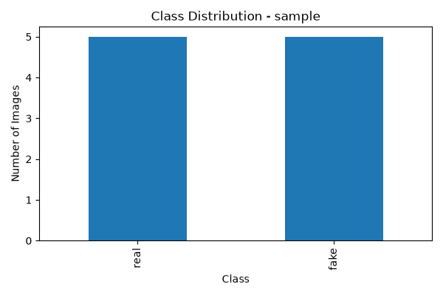

Table 4.1 AI Image Generators Used in This Research
Generator | Purpose
Midjourney | Commercial diffusion-based image generator
Stable Diffusion V5 (SDV5) | Open-source diffusion model
GLIDE | Diffusion-based image generation model
BigGAN | GAN-based image generator
ADM | Denoising diffusion model
Wukong | Large-scale diffusion model
VQDM | Vector Quantized Diffusion Model
(We'll later add citations for each generator from the appropriate papers.)

4.4 Dataset Statistics
Exploratory Data Analysis (EDA) was conducted before model development to understand the characteristics of the dataset and to verify the integrity of the images.
The EDA process analyzed:
- Number of images
- Image formats
- Image resolutions
- Class distribution
- Dataset balance
The analysis confirmed that the Tiny GenImage dataset contains balanced numbers of real and AI-generated images for each generator, making it appropriate for supervised binary image classification.

Table 4.2 Example EDA Results (Midjourney Training Set)
Property | Value
Total Images | 4,000
Real Images | 2,000
AI Images | 2,000
JPEG Images | 2,000
PNG Images | 2,000
Average Width | 746.70 px
Average Height | 712.21 px

4.5 Data Preprocessing
Before training, all images were preprocessed to ensure consistency across different CNN architectures.
The preprocessing pipeline included:
- Image resizing
- Tensor conversion
- Pixel normalization using ImageNet statistics
- Data augmentation for training images
Data augmentation techniques included random horizontal flipping and other standard transformations to improve model generalization and reduce overfitting during training.

4.6 Dataset Preparation for Training
Two different training strategies were implemented throughout this research.

Strategy 1 – Single-Generator Training
Each CNN model was trained using images from only one AI image generator before being evaluated on all other generators.
This experiment was designed to evaluate the cross-generator generalization capability of each CNN architecture.

Strategy 2 – Mixed-Generator Training
A second dataset was created by combining images from multiple AI image generators.
The mixed dataset contained training images from:
- Midjourney
- Stable Diffusion V5
- GLIDE
This strategy was designed to investigate whether exposure to multiple AI generators during training could improve model robustness when evaluated on previously unseen generators.
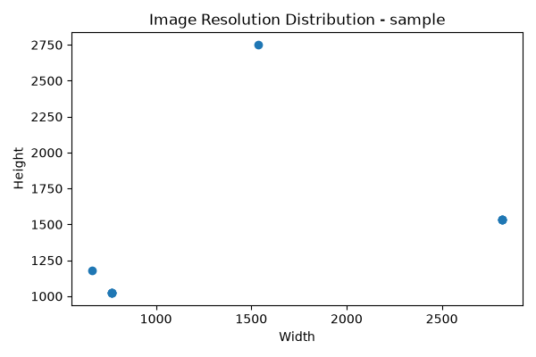

4.7 Current Dataset Preparation Status

Table 4.3 Dataset Preparation Progress
Task | Status
Tiny GenImage Downloaded | ✅
Dataset Verified | ✅
Directory Structure Confirmed | ✅
Exploratory Data Analysis Completed | ✅
Image Preprocessing Implemented | ✅
Single-Generator Dataset Created | ✅
Mixed-Generator Dataset Created | ✅
Dataset Successfully Loaded in PyTorch | ✅

5.Proposed Methodology and Model Architecture

5.1 Overview of the Proposed Framework
This research proposes a transfer learning-based framework for detecting AI-generated images using convolutional neural networks (CNNs). The overall methodology consists of five major stages: dataset preparation, image preprocessing, model training, performance evaluation, and comparative analysis.
Unlike conventional image classification studies that evaluate a single model, this research compares multiple CNN architectures under identical experimental settings. Furthermore, the framework evaluates both single-generator and mixed-generator training strategies to investigate their effects on cross-generator generalization.
The complete methodology adopted in this research is illustrated in Figure 5.1.

Figure 5.1 Proposed Research Methodology
Tiny GenImage Dataset
│
▼
Exploratory Data Analysis
│
▼
Image Preprocessing
│
▼
Transfer Learning Models
│
▼
Training Phase
┌─────────────┐
│ │
▼ ▼
Single Mixed Generator
Generator Training
Training
│ │
└──────┬──────┘
▼
Cross-generator Evaluation
▼
Statistical Comparison
▼
Result Analysis

5.2 Image Preprocessing
Before model training, all images were preprocessed to ensure compatibility with the selected CNN architectures. The preprocessing pipeline standardized the input images while preserving important visual characteristics required for AI-generated image detection.
The preprocessing pipeline consisted of the following steps:
- Image resizing
- Conversion to PyTorch tensors
- Pixel normalization using ImageNet statistics
- Data augmentation for the training dataset
During training, random data augmentation techniques such as horizontal flipping were applied to improve model robustness and reduce overfitting. Validation images were preprocessed using only deterministic transformations to ensure fair model evaluation.

5.3 Transfer Learning
Training deep neural networks from scratch requires millions of labelled images and substantial computational resources. To overcome these limitations, this research adopts a transfer learning approach.
Transfer learning enables models pre-trained on the ImageNet dataset to reuse previously learned visual representations such as edges, textures and object shapes. The final classification layer of each model was replaced with a binary classifier to distinguish between authentic and AI-generated images.
This approach significantly reduces training time while maintaining competitive performance for image classification tasks.

5.4 Selected CNN Architectures
Three CNN architectures were selected for comparative evaluation based on their popularity, computational efficiency and performance in image recognition tasks.

5.4.1 ResNet18
ResNet18 is a residual convolutional neural network consisting of 18 layers. The residual learning mechanism allows gradients to propagate more effectively during training, reducing the vanishing gradient problem commonly observed in deep neural networks.
ResNet18 was selected because it provides a lightweight baseline architecture with relatively low computational complexity while maintaining strong classification performance.
Advantages
- Lightweight architecture
- Fast training speed
- Lower computational requirements
- Well-established benchmark model

5.4.2 EfficientNet-B0
- EfficientNet-B0 introduces compound scaling, which simultaneously scales network depth, width and image resolution using a balanced approach.
- Compared with traditional CNN architectures, EfficientNet achieves competitive performance while requiring fewer model parameters.
- This model was selected to evaluate whether efficient network scaling improves AI-generated image detection performance.
Advantages
- High parameter efficiency
- Lower memory usage
- Strong image classification performance
- Suitable for transfer learning

5.4.3 ConvNeXt-Tiny
- ConvNeXt-Tiny is a modern convolutional neural network architecture inspired by the design principles of Vision Transformers while maintaining a fully convolutional structure.
- ConvNeXt incorporates several architectural improvements including larger convolution kernels, updated normalization strategies and improved training techniques.
- It was selected because recent research has demonstrated that ConvNeXt achieves state-of-the-art CNN performance on many computer vision tasks.
Advantages
- Modern CNN architecture
- Excellent feature extraction capability
- Strong transfer learning performance
- Competitive accuracy on image recognition benchmarks

5.5 Experimental Design
To comprehensively evaluate the proposed framework, four experimental settings were designed.
Table 5.1 Experimental Design
Experiment | Description | Purpose
E1 | Single-generator training | Baseline performance
E2 | Cross-generator evaluation | Measure generalization
E3 | Mixed-generator training | Improve robustness
E4 | Generator comparison | Analyze generator difficulty
Each experiment investigates a different aspect of AI-generated image detection. Together, these experiments provide a comprehensive evaluation of model accuracy, robustness and generalization across multiple AI image generators.

5.6 Performance Evaluation Metrics
The trained models were evaluated using several commonly adopted classification metrics.
These include:
- Accuracy
- Precision
- Recall
- F1-score
- Confusion Matrix
Accuracy provides the overall classification performance, while Precision and Recall measure the correctness of predictions for each class. The F1-score balances Precision and Recall into a single metric. Confusion matrices were used to visualize the distribution of correctly and incorrectly classified images, enabling detailed performance analysis.

6.Experimental Results

6.1 Experimental Overview
To evaluate the proposed AI-generated image detection framework, a series of experiments were conducted using the Tiny GenImage dataset. Three transfer learning CNN architectures, namely ResNet18, EfficientNet-B0 and ConvNeXt-Tiny, were evaluated under multiple experimental settings. The experiments investigated the performance of single-generator training, cross-generator evaluation, mixed-generator training and generator-specific learning.
All experiments were performed using the same preprocessing pipeline and training configuration to ensure fair comparison between models. Performance was evaluated using Accuracy, Precision, Recall, F1-score and Confusion Matrix analysis.
The experimental results presented in this chapter represent the first phase of the research and provide the basis for selecting the most suitable model for larger-scale experiments during the next phase of the dissertation.

6.2 Single-Generator Training Results

Table 6.1 Performance of CNN Models on Midjourney Validation Dataset
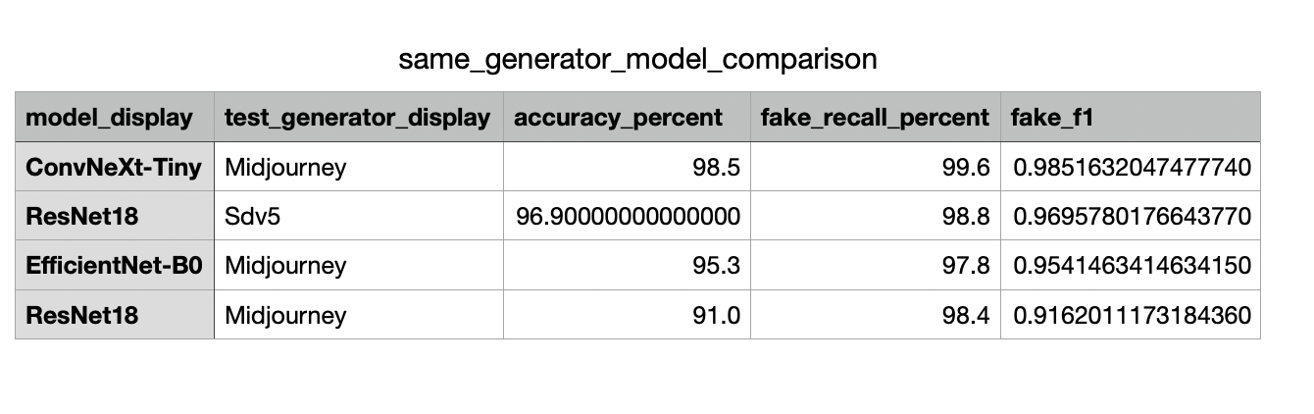
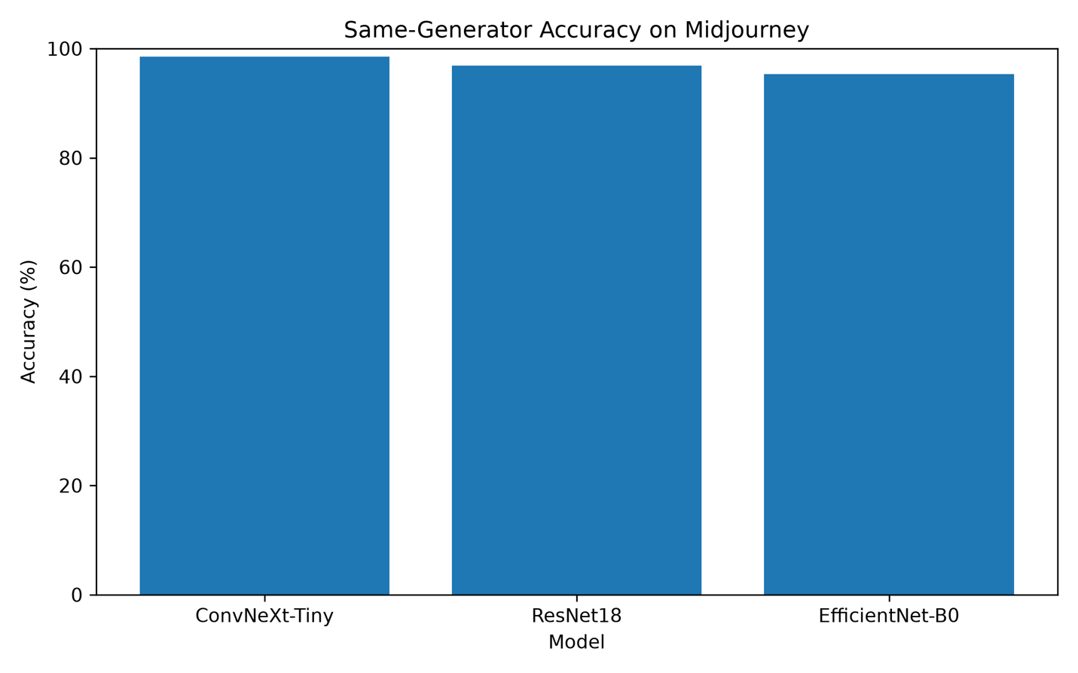
Fig 6.1 Same Generator Comparison (Midjourney)
Discussion
Table 6.1 demonstrates that all three transfer learning models achieved strong performance when evaluated on the same generator used during training. ConvNeXt-Tiny obtained the highest overall accuracy of 98.50%, indicating superior feature extraction capability for Midjourney-generated images. EfficientNet-B0 achieved competitive performance while maintaining a smaller computational footprint. Although ResNet18 produced the lowest overall accuracy among the three architectures, its simpler architecture provides an important baseline for comparison throughout the remaining experiments.

6.3 Cross-Generator Generalization
To evaluate the robustness of the proposed transfer learning models, cross-generator experiments were conducted using images generated by seven different AI image generators. Unlike same-generator evaluation, cross-generator evaluation measures the ability of a model to generalize to unseen generators that were not necessarily represented during training. This experiment is particularly important because real-world AI image detection systems are expected to identify images generated by a wide range of current and future image generation models

Table 6.2 Average Cross-Generator Model Comparison
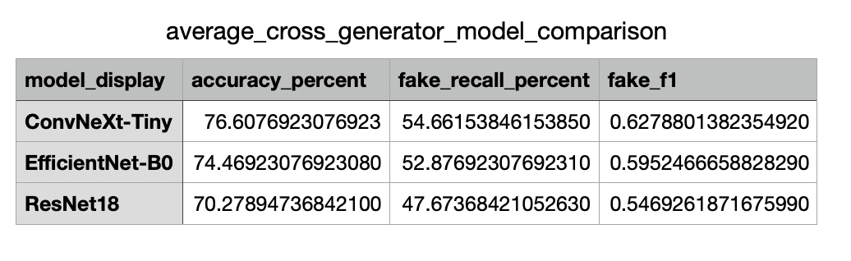
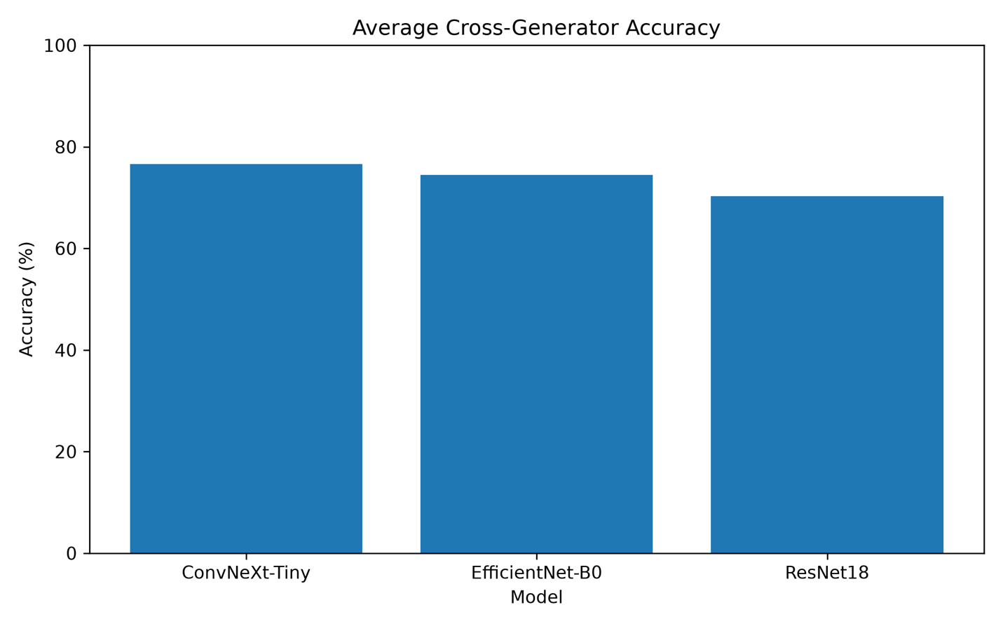
Fig 6.2 Average Cross-Generator Accuracy of the Evaluated CNN Architectures
The average cross-generator results demonstrate that ConvNeXt-Tiny achieved the highest overall performance with an average accuracy of 76.61%, followed by EfficientNet-B0 (74.47%) and ResNet18 (70.28%). The results indicate that modern CNN architectures can provide stronger feature representations that improve generalization across multiple AI image generators.
Although the performance differences between ConvNeXt-Tiny and EfficientNet-B0 are relatively small, both models consistently outperformed ResNet18 in terms of average accuracy. This suggests that deeper and more advanced feature extraction techniques contribute positively to AI-generated image detection when evaluated on unseen generators.
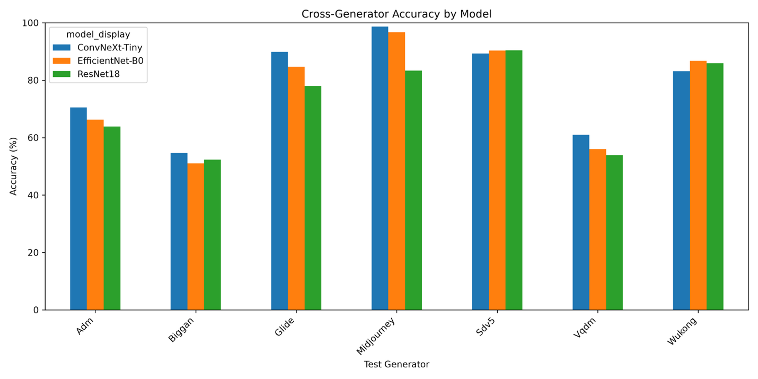
Fig 6.3 Cross-Generator Classification Accuracy of each CNN Architecture across Different AI Image Generators
Discussion
Figure 6.3 provides a detailed comparison of model performance across individual AI image generators. The results show that detection performance varies considerably depending on the image generator used for evaluation.
All three CNN architectures achieved their highest accuracies on Midjourney, where ConvNeXt-Tiny reached approximately 98.5%. Similarly, high accuracies were observed for Stable Diffusion V5 (SDV5) and Wukong, indicating that these diffusion-based generators share visual characteristics that are effectively learned by the transfer learning models.
In contrast, substantially lower accuracies were obtained for BigGAN, ADM, and VQDM. These generators consistently produced the lowest detection performance across all three CNN architectures. This observation suggests that images generated by these models contain different visual distributions or generation artifacts, making them more difficult for CNN-based detectors to recognize.
Among the evaluated architectures, ConvNeXt-Tiny achieved the highest accuracy for most generators, whereas EfficientNet-B0 remained competitive across nearly all test sets. ResNet18 generally produced lower performance but still demonstrated stable behavior across different generators, making it a useful baseline architecture for comparison.
Overall, the results indicate that the choice of image generator has a significant impact on AI image detection performance. Consequently, evaluating models using multiple generators is essential for obtaining a realistic assessment of generalization capability.

6.4 Mixed-Generator Training
Mixed-generator training was introduced to investigate whether exposing CNN models to images generated by multiple AI image generators during training improves their ability to generalize to previously unseen generators. Unlike the single-generator experiments presented in the previous sections, the mixed training dataset combined images from Midjourney, Stable Diffusion V5 and GLIDE.
Table 6.3 compares the average cross-generator performance obtained using single-generator training and mixed-generator training.
The results indicate that mixed-generator training consistently improved the generalization performance of all evaluated CNN architectures. ConvNeXt-Tiny achieved the highest overall performance, followed by EfficientNet-B0 and ResNet18. These findings suggest that training on images from multiple generators enables the models to learn more diverse visual representations rather than features specific to a single generator.
Despite these improvements, the models continued to experience lower performance when evaluated on BigGAN and VQDM. This indicates that although mixed-generator training increases robustness, generator-specific characteristics remain a challenge for current CNN-based detection methods.
Overall, the experimental results support the hypothesis that mixed-generator training is a more effective strategy for improving cross-generator AI image detection than conventional single-generator training.

Table 6.3 Mixed-Generator Training Performance

